K A D Nadeeshan

E/13/234

CO323 - LAB 03

E/13/234

K A D Nadeeshan

*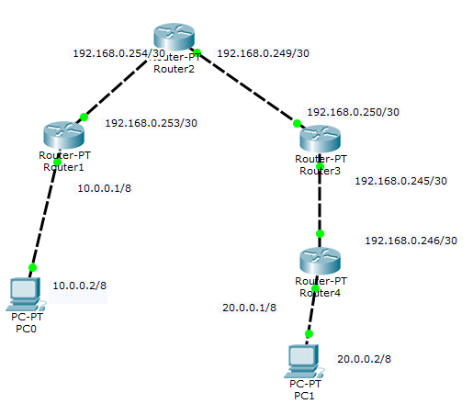*

1. *Static routing in the network*

* Router #1:

Codes: C - connected, S - static, I - IGRP, R - RIP, M - mobile, B - BGP

D - EIGRP, EX - EIGRP external, O - OSPF, IA - OSPF inter area

N1 - OSPF NSSA external type 1, N2 - OSPF NSSA external type 2

E1 - OSPF external type 1, E2 - OSPF external type 2, E - EGP

i - IS-IS, L1 - IS-IS level-1, L2 - IS-IS level-2, ia - IS-IS inter area

\* - candidate default, U - per-user static route, o - ODR

P - periodic downloaded static route

Gateway of last resort is not set

C 10.0.0.0/8 is directly connected, FastEthernet1/0

S 20.0.0.0/8 [1/0] via 192.168.0.254

192.168.0.0/30 is subnetted, 3 subnets

S 192.168.0.244 [1/0] via 192.168.0.254

S 192.168.0.248 [1/0] via 192.168.0.254

C 192.168.0.252 is directly connected, FastEthernet0/0

* Router #2:

Codes: C - connected, S - static, I - IGRP, R - RIP, M - mobile, B - BGP

D - EIGRP, EX - EIGRP external, O - OSPF, IA - OSPF inter area

N1 - OSPF NSSA external type 1, N2 - OSPF NSSA external type 2

E1 - OSPF external type 1, E2 - OSPF external type 2, E - EGP

i - IS-IS, L1 - IS-IS level-1, L2 - IS-IS level-2, ia - IS-IS inter area

\* - candidate default, U - per-user static route, o - ODR

P - periodic downloaded static route

Gateway of last resort is not set

S 10.0.0.0/8 [1/0] via 192.168.0.253

S 20.0.0.0/8 [1/0] via 192.168.0.250

192.168.0.0/30 is subnetted, 3 subnets

S 192.168.0.244 [1/0] via 192.168.0.250

C 192.168.0.248 is directly connected, FastEthernet1/0

C 192.168.0.252 is directly connected, FastEthernet0/0

* Router #3:

Codes: C - connected, S - static, I - IGRP, R - RIP, M - mobile, B - BGP

D - EIGRP, EX - EIGRP external, O - OSPF, IA - OSPF inter area

N1 - OSPF NSSA external type 1, N2 - OSPF NSSA external type 2

E1 - OSPF external type 1, E2 - OSPF external type 2, E - EGP

i - IS-IS, L1 - IS-IS level-1, L2 - IS-IS level-2, ia - IS-IS inter area

\* - candidate default, U - per-user static route, o - ODR

P - periodic downloaded static route

Gateway of last resort is not set

S 10.0.0.0/8 [1/0] via 192.168.0.249

S 20.0.0.0/8 [1/0] via 192.168.0.246

192.168.0.0/30 is subnetted, 3 subnets

C 192.168.0.244 is directly connected, FastEthernet0/0

C 192.168.0.248 is directly connected, FastEthernet1/0

S 192.168.0.252 [1/0] via 192.168.0.249

* Router #4:

Codes: C - connected, S - static, I - IGRP, R - RIP, M - mobile, B - BGP

D - EIGRP, EX - EIGRP external, O - OSPF, IA - OSPF inter area

N1 - OSPF NSSA external type 1, N2 - OSPF NSSA external type 2

E1 - OSPF external type 1, E2 - OSPF external type 2, E - EGP

i - IS-IS, L1 - IS-IS level-1, L2 - IS-IS level-2, ia - IS-IS inter area

\* - candidate default, U - per-user static route, o - ODR

P - periodic downloaded static route

Gateway of last resort is not set

S 10.0.0.0/8 [1/0] via 192.168.0.245

C 20.0.0.0/8 is directly connected, FastEthernet1/0

192.168.0.0/30 is subnetted, 3 subnets

C 192.168.0.244 is directly connected, FastEthernet0/0

S 192.168.0.248 [1/0] via 192.168.0.245

S 192.168.0.252 [1/0] via 192.168.0.245

* Assign the ip address to the routers
  + Router 1:

Router(config)#interface FastEthernet0/0

Router(config-if)#ip address 10.0.0.1 255.0.0.0

Router(config-if)# no shutdown

For every routers this command is used.

* IP route configurations

Router #1:

Router(config)#ip route 20.0.0.0 255.0.0.0 192.168.0.254

Router(config)#ip route 192.168.0.244 255.255.255.252 192.168.0.254

Router(config)#ip route 192.168.0.248 255.255.255.252 192.168.0.254

Router #2:

Router(config)#ip route 20.0.0.0 255.0.0.0 192.168.0.250

Router(config)#ip route 10.0.0.0 255.0.0.0 192.168.0.253

Router(config)#ip route 192.168.0.244 255.255.255.252 192.168.0.250

Router #3:

Router(config)#ip route 20.0.0.0 255.0.0.0 192.168.0.246

Router(config)#ip route 10.0.0.0 255.0.0.0 192.168.0.249

Router(config)#ip route 192.168.0.252 255.255.255.252 192.168.0.249

Router #4:

Router(config)#ip route 10.0.0.0 255.0.0.0 192.168.0.245

Router(config)#ip route 192.168.0.248 255.255.255.252 192.168.0.245

Router(config)#ip route 192.168.0.252 255.255.255.252 192.168.0.245

1. *RIP Routing*

* Router #1:

Codes: C - connected, S - static, I - IGRP, R - RIP, M - mobile, B - BGP

D - EIGRP, EX - EIGRP external, O - OSPF, IA - OSPF inter area

N1 - OSPF NSSA external type 1, N2 - OSPF NSSA external type 2

E1 - OSPF external type 1, E2 - OSPF external type 2, E - EGP

i - IS-IS, L1 - IS-IS level-1, L2 - IS-IS level-2, ia - IS-IS inter area

\* - candidate default, U - per-user static route, o - ODR

P - periodic downloaded static route

Gateway of last resort is not set

C 10.0.0.0/8 is directly connected, FastEthernet1/0

R 20.0.0.0/8 [120/3] via 192.168.0.254, 00:00:11, FastEthernet0/0

192.168.0.0/30 is subnetted, 3 subnets

R 192.168.0.244 [120/2] via 192.168.0.254, 00:00:11, FastEthernet0/0

R 192.168.0.248 [120/1] via 192.168.0.254, 00:00:11, FastEthernet0/0

C 192.168.0.252 is directly connected, FastEthernet0/0

* Router #2:

Codes: C - connected, S - static, I - IGRP, R - RIP, M - mobile, B - BGP

D - EIGRP, EX - EIGRP external, O - OSPF, IA - OSPF inter area

N1 - OSPF NSSA external type 1, N2 - OSPF NSSA external type 2

E1 - OSPF external type 1, E2 - OSPF external type 2, E - EGP

i - IS-IS, L1 - IS-IS level-1, L2 - IS-IS level-2, ia - IS-IS inter area

\* - candidate default, U - per-user static route, o - ODR

P - periodic downloaded static route

Gateway of last resort is not set

R 10.0.0.0/8 [120/1] via 192.168.0.253, 00:00:25, FastEthernet0/0

R 20.0.0.0/8 [120/2] via 192.168.0.250, 00:00:08, FastEthernet1/0

192.168.0.0/30 is subnetted, 3 subnets

R 192.168.0.244 [120/1] via 192.168.0.250, 00:00:08, FastEthernet1/0

C 192.168.0.248 is directly connected, FastEthernet1/0

C 192.168.0.252 is directly connected, FastEthernet0/0

* Router #3:

Codes: C - connected, S - static, I - IGRP, R - RIP, M - mobile, B - BGP

D - EIGRP, EX - EIGRP external, O - OSPF, IA - OSPF inter area

N1 - OSPF NSSA external type 1, N2 - OSPF NSSA external type 2

E1 - OSPF external type 1, E2 - OSPF external type 2, E - EGP

i - IS-IS, L1 - IS-IS level-1, L2 - IS-IS level-2, ia - IS-IS inter area

\* - candidate default, U - per-user static route, o - ODR

P - periodic downloaded static route

Gateway of last resort is not set

R 10.0.0.0/8 [120/2] via 192.168.0.249, 00:00:18, FastEthernet1/0

R 20.0.0.0/8 [120/1] via 192.168.0.246, 00:00:11, FastEthernet0/0

192.168.0.0/30 is subnetted, 3 subnets

C 192.168.0.244 is directly connected, FastEthernet0/0

C 192.168.0.248 is directly connected, FastEthernet1/0

R 192.168.0.252 [120/1] via 192.168.0.249, 00:00:18, FastEthernet1/0

* Router #4:

Codes: C - connected, S - static, I - IGRP, R - RIP, M - mobile, B - BGP

D - EIGRP, EX - EIGRP external, O - OSPF, IA - OSPF inter area

N1 - OSPF NSSA external type 1, N2 - OSPF NSSA external type 2

E1 - OSPF external type 1, E2 - OSPF external type 2, E - EGP

i - IS-IS, L1 - IS-IS level-1, L2 - IS-IS level-2, ia - IS-IS inter area

\* - candidate default, U - per-user static route, o - ODR

P - periodic downloaded static route

Gateway of last resort is not set

R 10.0.0.0/8 [120/3] via 192.168.0.245, 00:00:20, FastEthernet0/0

C 20.0.0.0/8 is directly connected, FastEthernet1/0

192.168.0.0/30 is subnetted, 3 subnets

C 192.168.0.244 is directly connected, FastEthernet0/0

R 192.168.0.248 [120/1] via 192.168.0.245, 00:00:20, FastEthernet0/0

R 192.168.0.252 [120/2] via 192.168.0.245, 00:00:20, FastEthernet0/0

For this question also, the command that used to assign ip addresses to router interface is same as first question.

Configure the RIP as follows

Router #1:

Router(config)#router rip

Router(config-router)#network 10.0.0.0

Router(config-router)#network 192.168.0.252

Router #2:

Router(config)#router rip

Router(config-router)#network 192.168.0.252

Router(config-router)#network 192.168.0.248

Router #3:

Router(config)#router rip

Router(config-router)#network 192.168.0.248

Router(config-router)#network 192.168.0.244

Router #4:

Router(config)#router rip

Router(config-router)#network 20.0.0.0

Router(config-router)#network 192.168.0.244

1. 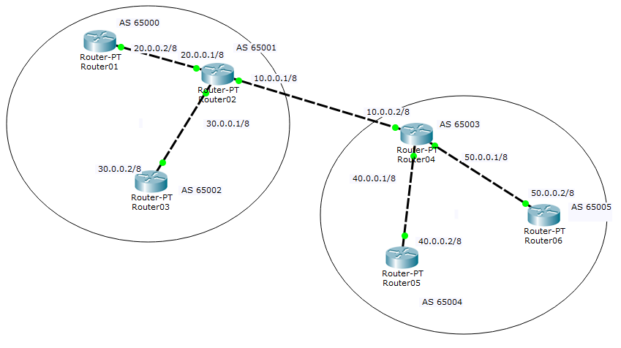BGP routing

* Router 01(A):
  + show ip bgp

BGP table version is 6, local router ID is 20.0.0.2

Status codes: s suppressed, d damped, h history, \* valid, > best, i - internal,

r RIB-failure, S Stale

Origin codes: i - IGP, e - EGP, ? - incomplete

Network Next Hop Metric LocPrf Weight Path

\*> 10.0.0.0/8 20.0.0.1 0 0 0 65001 i

\*> 20.0.0.0/8 0.0.0.0 0 0 32768 i

\*> 30.0.0.0/8 20.0.0.1 0 0 0 65001 i

\*> 40.0.0.0/8 20.0.0.1 0 0 0 65001 65003 i

\*> 50.0.0.0/8 20.0.0.1 0 0 0 65001 65003 i

* + show ip bgp summery

BGP router identifier 20.0.0.2, local AS number 65000

BGP table version is 6, main routing table version 6

5 network entries using 660 bytes of memory

5 path entries using 260 bytes of memory

4/4 BGP path/bestpath attribute entries using 736 bytes of memory

3 BGP AS-PATH entries using 72 bytes of memory

0 BGP route-map cache entries using 0 bytes of memory

0 BGP filter-list cache entries using 0 bytes of memory

Bitfield cache entries: current 1 (at peak 1) using 32 bytes of memory

BGP using 1760 total bytes of memory

BGP activity 5/0 prefixes, 5/0 paths, scan interval 60 secs

Neighbor V AS MsgRcvd MsgSent TblVer InQ OutQ Up/Down State/PfxRcd

20.0.0.1 4 65001 51 43 6 0 0 00:41:42 4

* + 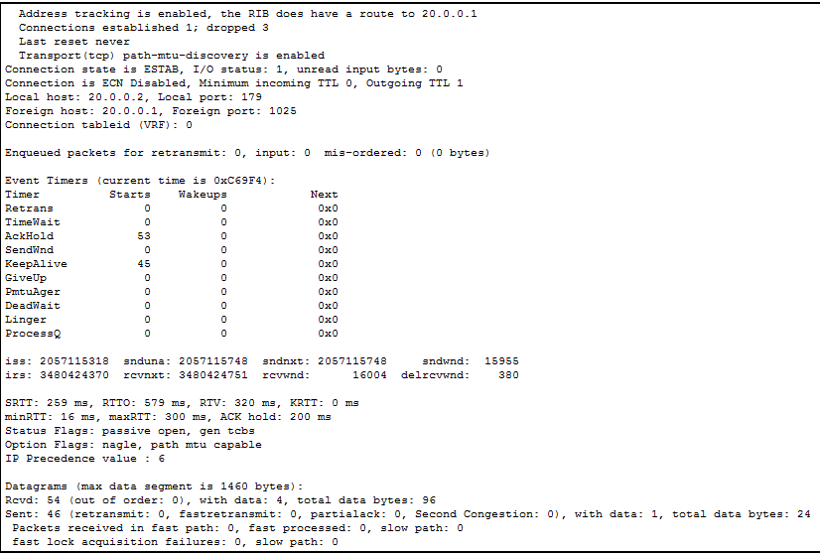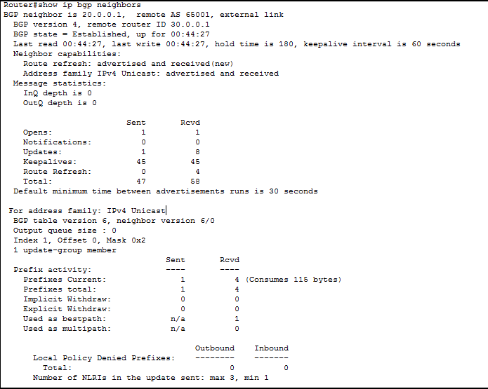show ip bgp neighbours
* Router 02(X):
  + show ip bgp

BGP table version is 8, local router ID is 30.0.0.1

Status codes: s suppressed, d damped, h history, \* valid, > best, i - internal,

r RIB-failure, S Stale

Origin codes: i - IGP, e - EGP, ? - incomplete

Network Next Hop Metric LocPrf Weight Path

\*> 10.0.0.0/8 0.0.0.0 0 0 32768 i

\* 10.0.0.2 0 0 0 65003 i

\* 20.0.0.0/8 20.0.0.2 0 0 0 65000 i

\*> 30.0.0.0/8 0.0.0.0 0 0 32768 i

\* 30.0.0.2 0 0 0 65002 i

\*> 40.0.0.0/8 10.0.0.2 0 0 0 65003 i

\*> 50.0.0.0/8 10.0.0.2 0 0 0 65003 i

* + show ip bgp summery

BGP router identifier 30.0.0.1, local AS number 65001

BGP table version is 8, main routing table version 6

7 network entries using 924 bytes of memory

7 path entries using 364 bytes of memory

5/2 BGP path/bestpath attribute entries using 644 bytes of memory

4 BGP AS-PATH entries using 96 bytes of memory

0 BGP route-map cache entries using 0 bytes of memory

0 BGP filter-list cache entries using 0 bytes of memory

Bitfield cache entries: current 1 (at peak 1) using 32 bytes of memory

BGP using 2060 total bytes of memory

BGP activity 5/0 prefixes, 7/0 paths, scan interval 60 secs

Neighbor V AS MsgRcvd MsgSent TblVer InQ OutQ Up/Down State/PfxRcd

20.0.0.2 4 65000 57 56 8 0 0 00:54:57 4

30.0.0.2 4 65002 53 52 8 0 0 00:50:29 4

10.0.0.2 4 65003 58 51 8 0 0 00:49:29 4

* + show ip bgp neighbours

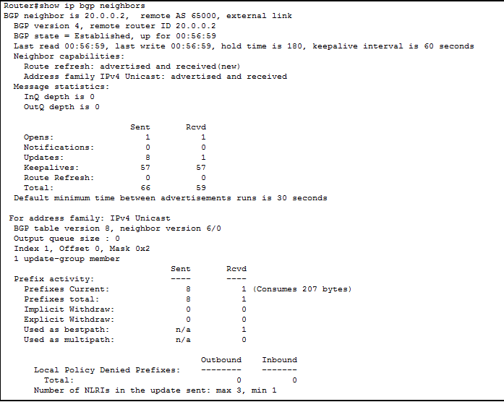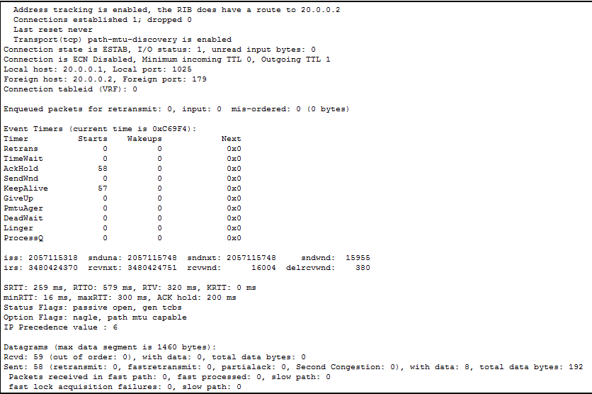



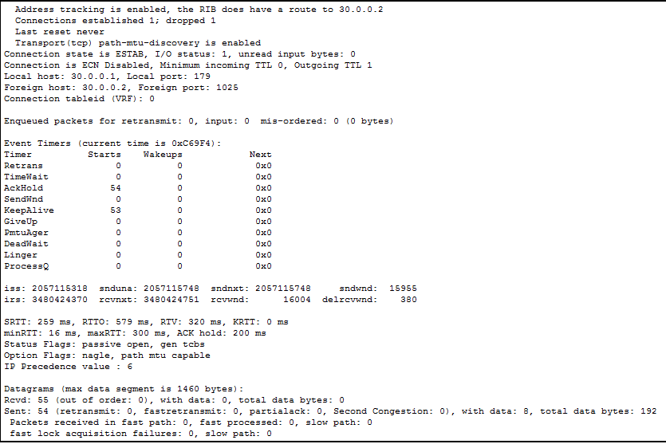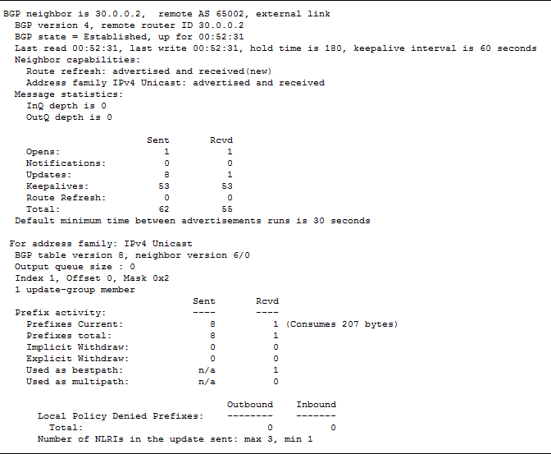

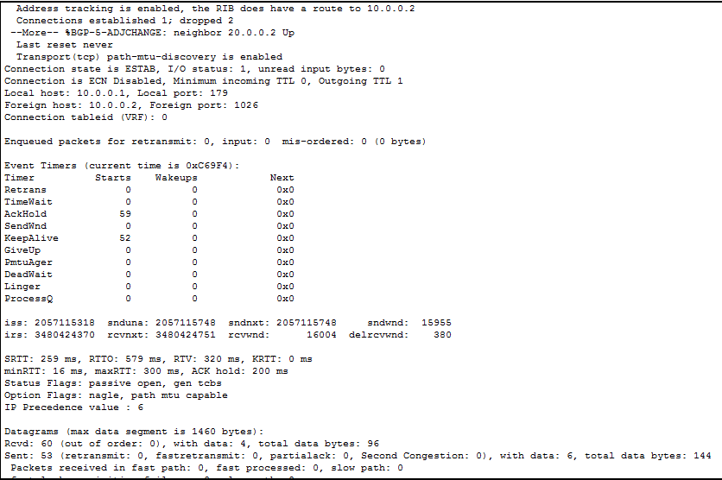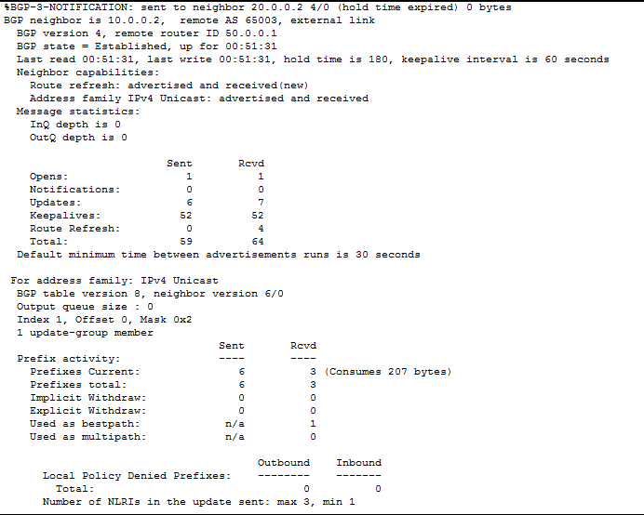

* Router 04(Y):
  + show ip bgp

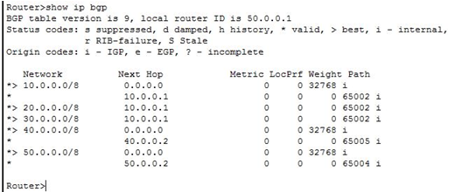

* + show ip bgp summery

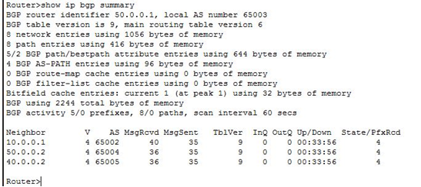

* + show ip bgp neighbours

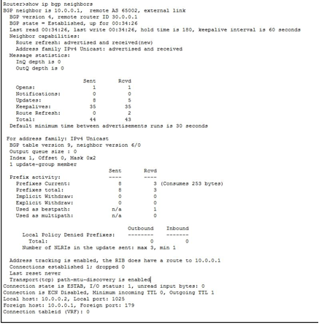

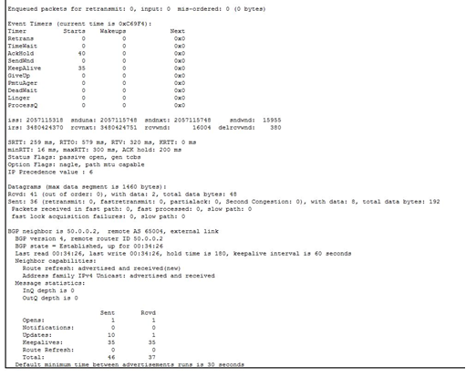

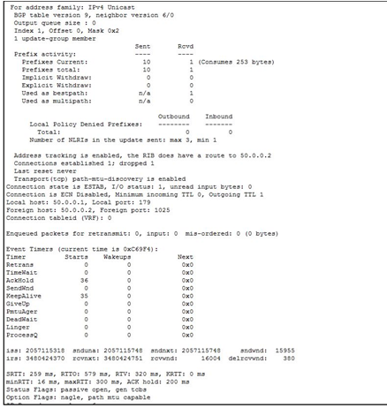

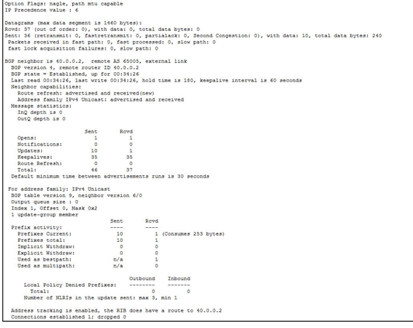

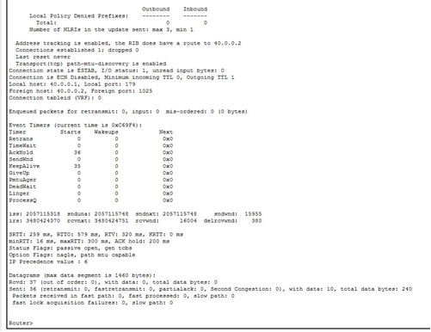

BGP configuration of the routers

For this question also, the command that used to assign ip addresses to router interface is same as first question.

Here how to give bgp configurations

Router 01(A)

Router(config)#router bgp 65000

Router(config-router)#neighbor 20.0.0.1 remote-as 65002

Router(config-router)#network 20.0.0.0 mask 255.0.0.0

Router 02(X)

Router(config)#router bgp 65002

Router(config-router)#neighbor 10.0.0.2 remote-as 65003

Router(config-router)#network 10.0.0.0 mask 255.0.0.0

Router(config-router)#neighbor 20.0.0.2 remote-as 65000

Router(config-router)#network 20.0.0.0 mask 255.0.0.0

Router(config-router)#neighbor 30.0.0.2 remote-as 65001

Router(config-router)#network 30.0.0.0 mask 255.0.0.0

Router 03(B)

Router(config)#router bgp 65001

Router(config-router)#neighbor 30.0.0.1 remote-as 65002

Router(config-router)#network 30.0.0.0 mask 255.0.0.0

Router 04(Y)

Router(config)#router bgp 65003

Router(config-router)#neighbor 10.0.0.1 remote-as 65003

Router(config-router)#network 10.0.0.0 mask 255.0.0.0

Router(config-router)#neighbor 40.0.0.2 remote-as 65005

Router(config-router)#network 40.0.0.0 mask 255.0.0.0

Router(config-router)#neighbor 50.0.0.2 remote-as 65004

Router(config-router)#network 50.0.0.0 mask 255.0.0.0

Router 05(C)

Router(config)#router bgp 65005

Router(config-router)#neighbor 40.0.0.1 remote-as 65003

Router(config-router)#network 40.0.0.0 mask 255.0.0.0

Router 06(D)

Router(config)#router bgp 65004

Router(config-router)#neighbor 50.0.0.1 remote-as 65003

Router(config-router)#network 50.0.0.0 mask 255.0.0.0